Note: You can print this (or any page) from your web browser by selecting File/Print. This information is provided for your personal use only and is not to be redistributed without permission of the author. This tip covers Photoshop 3 and Photoshop 4.

1. Start with an image, 200 pixels by 40 pixels, and fill with a pale color.
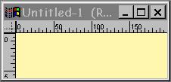
2. The second step is to create a shadow layer for the embossed type or graphic. Select a darker version of the background color, and use the type tool to create type. Apply Filter/Blur/Blur More. If you're using version 4 or 5 of Photoshop, you'll need to deselect the Preserve Transparency Checkbox (the shortcut is using the / key) before you blur. You can also create the shadow layer by duplicating the original type layer, then selecting Image/Adjust/Hue-Saturation-Brilliance, and tweaking the Lightness slider to the left, then blurring.
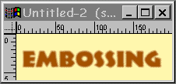
3. The third step is to create a highlight. Select white for the foreground color, and again use the type tool to create the type. The size and typeface should remain the same. Use the arrow keys to nudge the highlight copy of the type so that it is offset from the shadow copy, as shown in the example below.
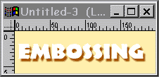
4. The last step is to use the eyedropper tool to set the foreground color to be the same color that the image began with. Again, use the type tool to create a third copy of the type. Use the arrow keys to nudge to position the type into position as shown in the example below.
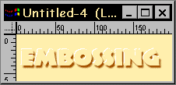
Don't forget that you can use graphics as well as type with this tip! Experiment with symbol (dingbat) typefaces, too!
Home | Guestbook | Tip Menu | Tip #13

