 |  |  | 



Using a flatbed scanner, you can use virtually any object that will fit onto the scanner as a background for your web page. The example below shows just a few of the amazing possibilities that ordinary objects offer for creative backgrounds.

The objects used in the examples above include, from left to right, a bit of fabric, a handful of plastic "jewels" from a craft supply store, a swatch of handmade paper, a paper doily, breakfast cereal, and an artichoke. Think of the infinite variety of creative backgrounds you can create from household and found objects.
Anything from a handful of costume jewelry to a scattering of leaves can become a background for your web page. This tutorial does require the use of a flatbed scanner. Obviously, you couldn't feed half an artichoke or a handful of dry pasta through a handheld or single-sheet fed scanner. I'd also suggest, if you'll be scanning messy or rough objects to protect the glass on your scanner by covering it with a sheet of clear acetate, available at art supply stores. You can also enclose the objects you'll be scanning in a plastic bag.
This tutorial will show you how to scan, make a simple adjustment, and create a seamless background from some colorful candy.We'll be covering more aspects of scanning in Chapter 6 of Creating Great Web Graphics.
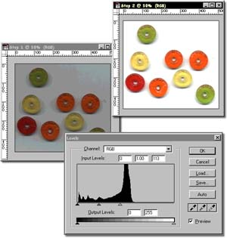
1. Select File/Import, and select your scanner (your scanner drivers, obviously, would need to have been installed prior to this step). You'll want to scan a little larger than the image will show up on your web page, so scan your objects in at about 120 dpi. Your scan will probably be dark, gray in tone, and have small artifacts (what I call glitches) visible, but that's okay.
2. You'll fix the overall cast of the image first. This image scanned in too dark, as shown above. By selecting Image/Adjust/Levels, and dragging the right (or white) input slider towards the center, you'll lighten the highlights and midtones in the image.
3.Select Image/Offset with the Horizontal and Vertical amounts set to about half of your file size. Make sure that the Wrap Around radio button is selected.
4. There's a gap in the image, so I selected a portion of the image, feathered the selection using Select/Feather, then copied (Control+C on Windows, Command+C on the Mac) the selection, and pasted the selection (Control+V on Windows, Command+V on the Mac) to cover the blank area. Paint out any glitches in your image using the paintbrush, and resize the image by selecting Image/Image Size and changing the pixel size.
More About the Book | More Tutorials

